Unit II Transport And Application Layers

Topics to be covered:

Traditional TCP – Classical TCP improvements – WAP, WAP 2.0.

1.Traditional TCP
This section highlights several mechanisms of the transmission control protocol (TCP) that influence the efficiency of TCP in a mobile environment.

1.1 Congestion control
A transport layer protocol such as TCP has been designed for fixed networks with fixed end-systems. Data transmission takes place using network adapters, fiber optics, copper wires, special hardware for routers etc. This hardware typically works without introducing transmission errors. If the software is mature enough, it will not drop packets or flip bits, so if a packet on its way from a sender to a receiver is lost in a fixed network, it is not because of hardware or software errors. The probable reason for a packet loss in a fixed network is a temporary overload some point in the transmission path, i.e., a state of congestion at a node. Congestion may appear from time to time even in carefully designed networks. The packet buffers of a router are filled and the router cannot forward the packets fast enough because the sum of the input rates of packets destined for one output link is higher than the capacity of the output link. The only thing a router can do in this situation is to drop packets. A dropped packet is lost for the transmission, and the receiver notices a gap in the packet stream. Now the receiver does not directly tell the sender which packet is missing, but continues to acknowledge all in-sequence packets up to the missing one.
The sender notices the missing acknowledgement for the lost packet and assumes a packet loss due to congestion. Retransmitting the missing packet and continuing at full sending rate would now be unwise, as this might only increase the congestion. Although it is not guaranteed that all packets of the TCP connection take the same way through the network, this assumption holds for most of the packets. To mitigate congestion, TCP slows down the transmission rate dramatically. All other TCP connections experiencing the same congestion do exactly the same so the congestion is soon resolved. This cooperation of TCP connections in the internet is one of the main reasons for its survival as it is today. Using UDP is not a solution, because the throughput is higher compared to a TCP connection just at the beginning. As soon as everyone uses UDP, this advantage disappears. After that, congestion is standard and data transmission quality is unpredictable. Even under heavy load, TCP guarantees at least sharing of the bandwidth.

1.2 Slow start
TCP’s reaction to a missing acknowledgement is quite drastic, but it is necessary to get rid of congestion quickly. The behavior TCP shows after the detection of congestion is called slow start. The sender always calculates a congestion window for a receiver. The start size of the congestion window is one segment (TCP packet). The sender sends one packet and waits for acknowledgement. If this acknowledgement arrives, the sender increases the congestion window by one, now sending two packets (congestion window = 2). After arrival of the two corresponding acknowledgements, the sender again adds 2 to the congestion window, one for each of the acknowledgements. Now the congestion window equals 4. This scheme doubles the congestion window every time the acknowledgements come back, which takes one round trip time (RTT). This is called the exponential growth of the congestion window in the slow start mechanism. It is too dangerous to double the congestion window each time because the steps might become too large. The exponential growth stops at the congestion threshold. As soon as the congestion window reaches the congestion threshold, further increase of the transmission rate is only linear by adding 1 to the congestion window each time the acknowledgements come back. Linear increase continues until a time-out at the sender occurs due to a missing acknowledgement, or until the sender detects a gap in transmitted data because of continuous acknowledgements for the same packet. In either case the sender sets the congestion threshold to half of the current congestion window.
The congestion window itself is set to one segment and the sender starts sending a single segment. The exponential growth starts once more up to the new congestion threshold, then the window grows in linear fashion.

1.3 Fast retransmit/fast recovery
Two things lead to a reduction of the congestion threshold. One is a sender receiving continuous acknowledgements for the same packet. This informs the sender of two things. One is that the receiver got all packets up to the acknowledged packet in sequence. In TCP, a receiver sends acknowledgements only if it receives any packets from the sender. Receiving acknowledgements from a receiver also shows that the receiver continuously receives something from the sender. The gap in the packet stream is not due to severe congestion, but a simple packet loss due to a transmission error. The sender can now retransmit the missing packet(s) before the timer expires. This behavior is called fast retransmit. The receipt of acknowledgements shows that there is no congestion to justify a slow start. The sender can continue with the current congestion window. The sender performs a fast recovery from the packet loss. This mechanism can improve the efficiency of TCP dramatically. The other reason for activating slow start is a time-out due to a missing acknowledgement. TCP using fast retransmit/fast recovery interprets this congestion in the network and activates the slow start mechanism.

1.4 Implications on mobility
While slow start is one of the most useful mechanisms in fixed networks, it drastically decreases the efficiency of TCP if used together with mobile receivers or senders. The reason for this is the use of slow start under the wrong assumptions. From a missing acknowledgement, TCP concludes a congestion situation. While this may also happen in networks with mobile and wireless end-systems, it is not the main reason for packet loss. Error rates on wireless links are orders of magnitude higher compared to fixed fiber or copper links. Packet loss is much more common and cannot always be compensated for by layer 2 retransmissions (ARQ) or error correction (FEC). Trying to retransmit on layer 2 could, for example, trigger TCP retransmission
if it takes too long. Layer 2 now faces the problem of transmitting the same packet twice over a bad link. Detecting these duplicates on layer 2 is not an option, because more and more connections use end-to-end encryption, making it impossible to look at the packet. Mobility itself can cause packet loss.
There are many situations where a soft handover from one access point to another is not possible for a mobile end system. For example, when using mobile IP, there could still be some packets in transit to the old foreign agent while the mobile node moves to the new foreign agent. The old foreign agent may not be able to forward those packets to the new foreign agent or even buffer the packets if disconnection of the mobile node takes too long. This packet loss has nothing to do with wireless access but is caused by the problems of rerouting traffic. The TCP mechanism detecting missing acknowledgements via time-outs and concluding packet loss due to congestion cannot distinguish between the different causes. This is a fundamental design problem in TCP: An error control mechanism (missing acknowledgement due to a transmission error) is misused for congestion control (missing acknowledgement due to network overload).
In both cases packets are lost (either due to invalid checksums or to dropping in routers). However, the reasons are completely different. TCP cannot distinguish between these two different reasons. Standard TCP reacts with slow start if acknowledgements are missing, which does not help in the case of transmission errors over wireless links and which does not really help during handover. This behavior results in a severe performance degradation of an unchanged TCP if used together with wireless links or mobile nodes. However, one cannot change TCP completely just to support mobile users or wireless links. The same arguments that were given to keep IP unchanged also apply to TCP. The installed base of computers using TCP is too large to be changed and, more important, mechanisms such as slow start keep the internet
operable. Every enhancement to TCP, therefore, has to remain compatible with the standard TCP and must not jeopardize the cautious behavior of TCP in case of congestion. The following sections present some classical solutions before discussing current TCP tuning recommendations.

2. Classical TCP improvements
Together with the introduction of WLANs in the mid-nineties several research projects were started with the goal to increase TCP’s performance in wireless and mobile environments.

2.1 Indirect TCP
Two competing insights led to the development of indirect TCP (I-TCP). One is that TCP performs poorly together with wireless links, the other is that TCP within the fixed network cannot be changed. I-TCP segments a TCP connection into a fixed part and a wireless part. Figure shows an example with a mobile host connected via a wireless link and an access point to the ‘wired’ internet where the correspondent host resides. The correspondent node could also use wireless access. The following would then also be applied to the access link of the correspondent host. Standard TCP is used between the fixed computer and the access point. No computer in the internet recognizes any changes to TCP. Instead of the mobile host, the access point now terminates the standard TCP connection, acting as a proxy.
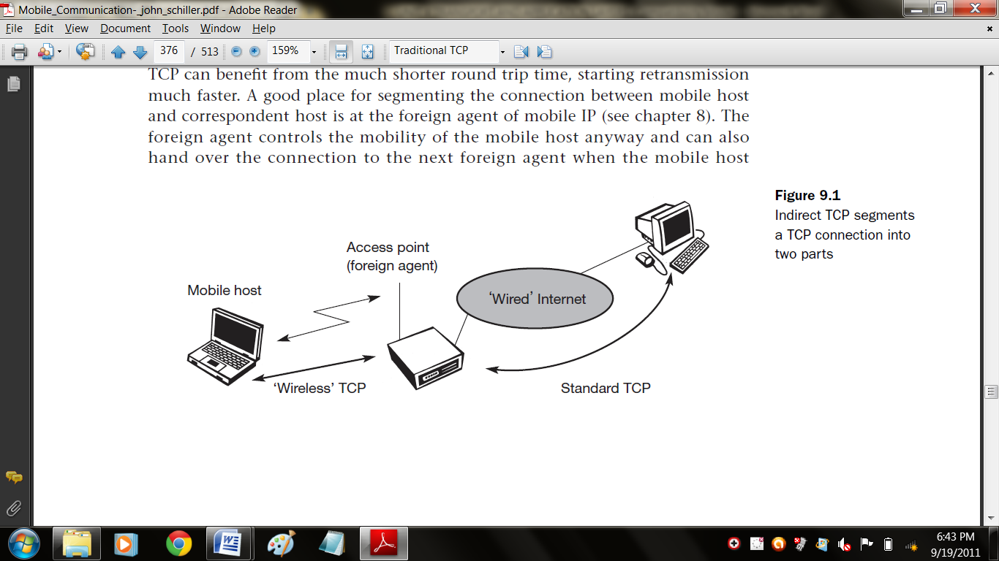
This means that the access point is now seen as the mobile host for the fixed host and as the fixed host for the mobile host. Between the access point and the mobile host, a special TCP, adapted to wireless links, is used. However, changing TCP for the wireless link is not a requirement. Even an unchanged TCP can benefit from the much shorter round trip time, starting retransmission much faster. A good place for segmenting the connection between mobile host and correspondent host is at the foreign agent of mobile IP. The foreign agent controls the mobility of the mobile host anyway and can also hand over the connection to the next foreign agent when the mobile host moves on. However, one can also imagine separating the TCP connections at a special server, e.g., at the entry point to a mobile phone network (e.g., IWF in GSM, GGSN in GPRS).
The correspondent host in the fixed network does not notice the wireless link or the segmentation of the connection. The foreign agent acts as a proxy and relays all data in both directions. If the correspondent host sends a packet, the foreign agent acknowledges this packet and tries to forward the packet to the mobile host. If the mobile host receives the packet, it acknowledges the packet. However, this acknowledgement is only used by the foreign agent. If a
packet is lost on the wireless link due to a transmission error, the correspondent host would not notice this. In this case, the foreign agent tries to retransmit this packet locally to maintain reliable data transport.
Similarly, if the mobile host sends a packet, the foreign agent acknowledges this packet and tries to forward it to the correspondent host. If the packet is lost on the wireless link, the mobile hosts notice this much faster due to the lower round trip time and can directly retransmit the packet. Packet loss in the wired network is now handled by the foreign agent. I-TCP requires several actions as soon as a handover takes place. As Figure demonstrates, not only the packets have to be redirected using, e.g., mobile IP.
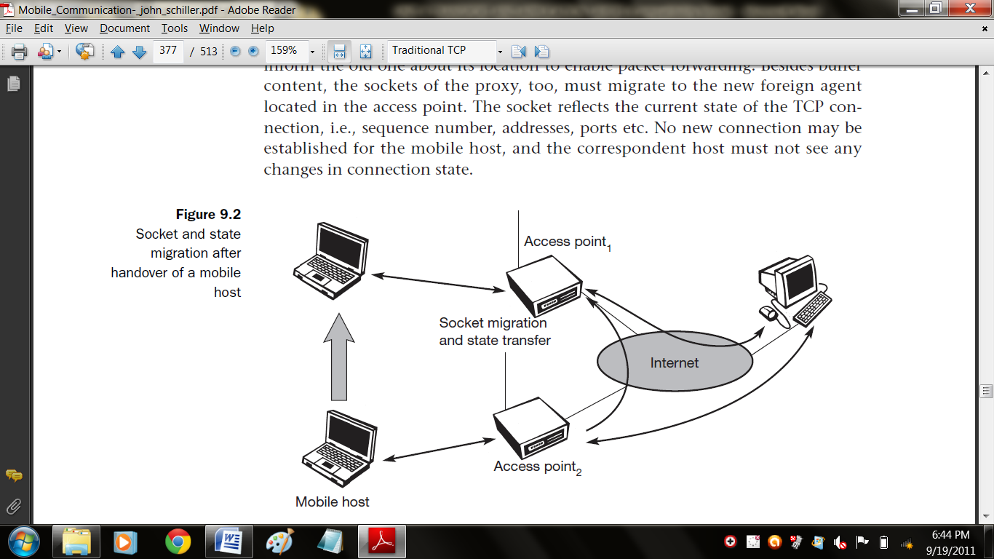
In the example shown, the access point acts as a proxy buffering packets for retransmission. After the handover, the old proxy must forward buffered data to the new proxy because it has already acknowledged the data. After registration with the new foreign agent, this new foreign agent can inform the old one about its location to enable packet forwarding. Besides buffer content, the sockets of the proxy, too, must migrate to the new foreign agent located in the access point. The socket reflects the current state of the TCP connection, i.e., sequence number, addresses, ports etc. No new connection may be established for the mobile host, and the correspondent host must not see any changes in connection state.

There are several advantages with I-TCP:

- I-TCP does not require any changes in the TCP protocol as used by the hosts in the fixed network or other hosts in a wireless network that do not use this optimization. All current optimizations for TCP still work between the foreign agent and the correspondent host.
- Due to the strict partitioning into two connections, transmission errors on the wireless link, i.e., lost packets, cannot propagate into the fixed network. Without partitioning, retransmission of lost packets would take place between mobile host and correspondent host across the whole network. Now only packets in sequence, without gaps leave the foreign agent.
- It is always dangerous to introduce new mechanisms into a huge network such as the internet without knowing exactly how they will behave. However, new mechanisms are needed to improve TCP performance (e.g., disabling slow start under certain circumstances), but with I-TCP only between the mobile host and the foreign agent. Different solutions can be tested or used at the same time without jeopardizing the stability of the internet. Furthermore, optimizing of these new mechanisms is quite simple because they only cover one single hop.
- The authors assume that the short delay between the mobile host and foreign agent could be determined and was independent of other traffic streams. An optimized TCP could use precise time-outs to guarantee retransmission as fast as possible. Even standard TCP could benefit from the short round trip time, so recovering faster from packet loss. Delay is much higher in a typical wide area wireless network than in wired networks due to FEC and MAC. GSM has a delay of up to 100 ms circuit switched, 200 ms and more packet switched (depending on packet size and current traffic). This is even higher than the delay on transatlantic links.
- Partitioning into two connections also allows the use of a different transport layer protocol between the foreign agent and the mobile host or the use of compressed headers etc. The foreign agent can now act as a gateway to translate between the different protocols.

But the idea of segmentation in I-TCP also comes with some disadvantages:

- The loss of the end-to-end semantics of TCP might cause problems if the foreign agent partitioning the TCP connection crashes. If a sender receives an acknowledgement, it assumes that the receiver got the packet. Receiving an acknowledgement now only means (for the mobile host and a correspondent host) that the foreign agent received the packet. The correspondent node does not know anything about the partitioning, so a crashing access node may also crash applications running on the correspondent node assuming reliable end-to-end delivery.
- In practical use, increased handover latency may be much more problematic. All packets sent by the correspondent host are buffered by the foreign agent besides forwarding them to the mobile host (if the TCP connection is split at the foreign agent). The foreign agent removes a packet from the buffer as soon as the appropriate acknowledgement arrives. If the mobile host now performs a handover to another foreign agent, it takes a while before the old foreign agent can forward the buffered data to the new foreign agent. During this time more packets may arrive. All these packets have to be forwarded to the new foreign agent first, before it can start forwarding the new packets redirected to it.
- The foreign agent must be a trusted entity because the TCP connections end at this point. If users apply end-to-end encryption, e.g., according to RFC 2401, the foreign agent has to be integrated into all security mechanisms.

2.2 Snooping TCP
One of the drawbacks of I-TCP is the segmentation of the single TCP connection into two TCP connections. This loses the original end-to-end TCP semantic. The following TCP enhancement works completely transparently and leaves the TCP end-to-end connection intact. The main function of the enhancement is to buffer data close to the mobile host to perform fast local retransmission in case of packet loss. A good place for the enhancement of TCP could be the foreign agent in the Mobile IP context.
In this approach, the foreign agent buffers all packets with destination mobile host and additionally ‘snoops’ the packet flow in both directions to recognize acknowledgements. The reason for buffering packets toward the mobile node is to enable the foreign agent to perform a local retransmission in case of packet loss on the wireless link. The foreign agent buffers every packet until it receives an acknowledgement from the mobile host. If the foreign agent does not receive an acknowledgement from the mobile host within a certain amount of time, either the packet or the acknowledgement has been lost. Alternatively, the foreign agent could receive a duplicate ACK which also shows the loss of a packet. Now the foreign agent retransmits the packet directly from the buffer, performing a much faster retransmission compared to the correspondent host. The time out for acknowledgements can be much shorter, because it reflects only the delay of one hop plus processing time.
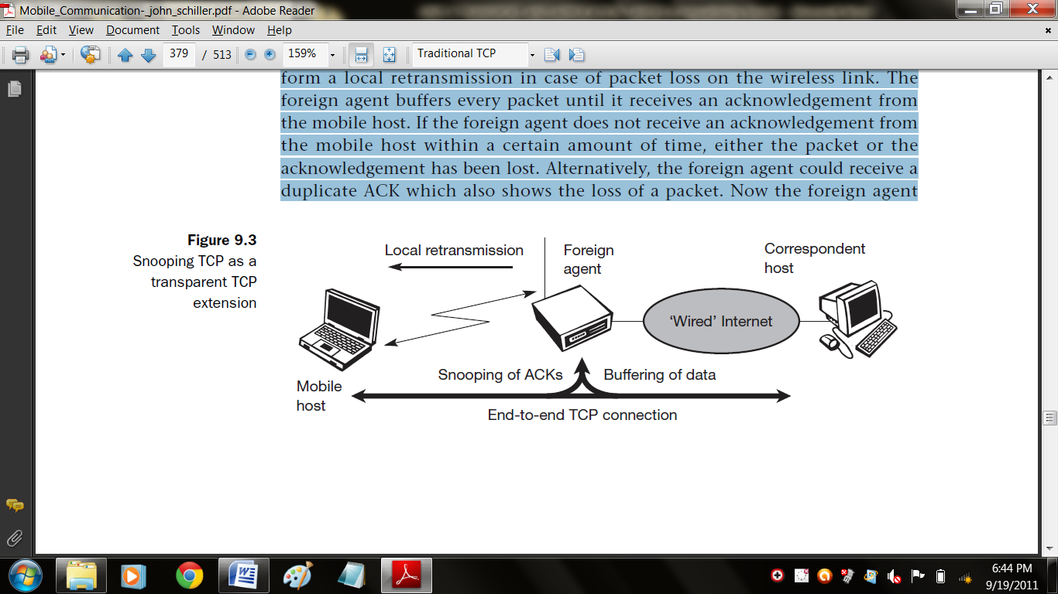

To remain transparent, the foreign agent must not acknowledge data to the correspondent host. This would make the correspondent host believe that the mobile host had received the data and would violate the end-to-end semantic in case of a foreign agent failure. However, the foreign agent can filter the duplicate acknowledgements to avoid unnecessary retransmissions of data from the correspondent host. If the foreign agent now crashes, the time-out of the correspondent host still works and triggers a retransmission. The foreign agent may discard duplicates of packets already retransmitted locally and acknowledged by the mobile host. This avoids unnecessary traffic on the wireless link.
Data transfer from the mobile host with destination correspondent host works as follows. The foreign agent snoops into the packet stream to detect gaps in the sequence numbers of TCP. As soon as the foreign agent detects a missing packet, it returns a negative acknowledgement (NACK) to the mobile host. The mobile host can now retransmit the missing packet immediately. Reordering of packets is done automatically at the correspondent host by TCP.

2.3 Mobile TCP
Dropping packets due to a handover or higher bit error rates is not the only phenomenon of wireless links and mobility, the occurrence of lengthy and/or frequent disconnections is another problem. Quite often mobile users cannot connect at all. One example is islands of wireless LANs inside buildings but no coverage of the whole campus
A TCP sender tries to retransmit data controlled by a retransmission timer that doubles with each unsuccessful retransmission attempt, up to a maximum of one minute (the initial value depends on the round trip time). This means that the sender tries to retransmit an unacknowledged packet every minute and will give up after 12 retransmissions. What happens if connectivity is back earlier than this? No data is successfully transmitted for a period of one minute.
The retransmission time-out is still valid and the sender has to wait. The sender also goes into slow-start because it assumes congestion. The proxy has to buffer more and more data, so the longer the period of disconnection, the more buffer is needed. If a handover follows the disconnection, which is typical, even more state has to be transferred to the new proxy. The snooping approach also suffers from being disconnected. The mobile will not be able to send ACKs so, snooping cannot help in this situation.
The M-TCP (mobile TCP) approach has the same goals as I-TCP and snooping TCP: to prevent the sender window from shrinking if bit errors or disconnection but not congestion cause current problems. M-TCP wants to improve overall throughput, to lower the delay, to maintain end-to-end semantics of TCP, and to provide a more efficient handover. Additionally, M-TCP is especially adapted to the problems arising from lengthy or frequent disconnections.
M-TCP splits the TCP connection into two parts as I-TCP does. An unmodified TCP is used on the standard host-supervisory host (SH) connection, while an optimized TCP is used on the SH-MH connection. The supervisory host is responsible for exchanging data between both parts similar to the proxy in ITCP. The M-TCP approach assumes a relatively low bit error rate on the wireless link. Therefore, it does not perform caching/retransmission of data via the SH. If a packet is lost on the wireless link, it has to be retransmitted by the original sender. This maintains the TCP end-to-end semantics. The SH monitors all packets sent to the MH and ACKs returned from the MH. If the SH does not receive an ACK for some time, it assumes that the MH is disconnected. It then chokes the sender by setting the sender’s window size to 0. Setting the window size to 0 forces the sender to go into persistent mode, i.e., the state of the sender will not change no matter how long the receiver is disconnected. This means that the sender will not try to retransmit data. As soon as the SH (either the old SH or a new SH) detects connectivity again, it reopens the window of the sender to the old value. The sender can continue sending at full speed. This mechanism does not require changes to the sender’s TCP.
The wireless side uses an adapted TCP that can recover from packet loss much faster. This modified TCP does not use slow start, thus, M-TCP needs a bandwidth manager to implement fair sharing over the wireless link.

The advantages of M-TCP are the following:

- It maintains the TCP end-to-end semantics. The SH does not send any ACK itself but forwards the ACKs from the MH.
- If the MH is disconnected, it avoids useless retransmissions, slow starts or breaking connections by simply shrinking the sender’s window to 0.
- Since it does not buffer data in the SH as I-TCP does, it is not necessary to forward buffers to a new SH. Lost packets will be automatically retransmitted to the new SH.

The lack of buffers and changing TCP on the wireless part also has some disadvantages:

- As the SH does not act as proxy as in I-TCP, packet loss on the wireless link due to bit errors is propagated to the sender. M-TCP assumes low bit error rates, which is not always a valid assumption.
- A modified TCP on the wireless link not only requires modifications to the MH protocol software but also new network elements like the bandwidth manager.

2.4 Fast retransmit/fast recovery
Moving to a new foreign agent can cause packet loss or time out at mobile hosts or corresponding hosts. TCP concludes congestion and goes into slow start, although there is no congestion.
As soon as the mobile host registers at a new foreign agent using mobile IP, it starts sending duplicated acknowledgements to correspondent hosts. The proposal is to send three duplicates. This force the corresponding host to go into fast retransmit mode and not to start slow start, i.e., the correspondent host continues to send with the same rate it did before the mobile host moved to another foreign agent. As the mobile host may also go into slow start after moving to a new foreign agent, this approach additionally puts the mobile host into fast retransmit. The mobile host retransmits all unacknowledged packets using the current congestion window size without going into slow start.
The advantage of this approach is its simplicity. Only minor changes in the mobile host’s software already result in a performance increase. No foreign agent or correspondent host has to be changed.
The main disadvantage of this scheme is the insufficient isolation of packet losses. Forcing fast retransmission increases the efficiency, but retransmitted packets still have to cross the whole network between correspondent host and mobile host. The approach focuses on loss due to handover: packet loss due to problems on the wireless link is not considered. This approach requires more cooperation between the mobile IP and TCP layer making it harder to change one without influencing the other.

2.5 Transmission/time-out freezing
While the approaches presented so far can handle short interruptions of the connection, either due to handover or transmission errors on the wireless link, some were designed for longer interruptions of transmission. Examples are the use of mobile hosts in a car driving into a tunnel, which loses its connection to, e.g., a satellite (however, many tunnels and subways provide connectivity via a mobile phone), or a user moving into a cell with no capacity left over. In this case, the mobile phone system will interrupt the connection. The reaction of TCP, even with the enhancements of above, would be a disconnection after a time out. Quite often, the MAC layer has already noticed connection problems, before the connection is actually interrupted from a TCP point of view. Additionally, the MAC layer knows the real reason for the interruption and does not assume congestion, as TCP would. The MAC layer can inform the TCP layer of an upcoming loss of connection or that the current interruption is not caused by congestion. TCP can now stop sending and ‘freezes’ the current state of its congestion window and further timers. If the MAC layer notices the upcoming interruption early enough, both the mobile and correspondent host can be informed. With a fast interruption of the wireless link, additional mechanisms in the access point are needed to inform the correspondent host of the reason for interruption. Otherwise, the correspondent host goes into slow start assuming congestion and finally breaks the connection.
As soon as the MAC layer detects connectivity again, it signals TCP that it can resume operation at exactly the same point where it had been forced to stop. For TCP time simply does not advance, so no timers expire.
The advantage of this approach is that it offers a way to resume TCP connections even after longer interruptions of the connection. It is independent of any other TCP mechanism, such as acknowledgements or sequence numbers, so it can be used together with encrypted data.
However, this scheme has some severe disadvantages. Not only does the software on the mobile host have to be changed, to be more effective the correspondent host cannot remain unchanged. All mechanisms rely on the capability of the MAC layer to detect future interruptions. Freezing the state of TCP does not help in case of some encryption schemes that use time-dependent random numbers. These schemes need resynchronization after interruption.

2.6 Selective retransmission
A very useful extension of TCP is the use of selective retransmission. TCP acknowledgements are cumulative, i.e., they acknowledge in-order receipt of packets up to a certain packet. If a single packet is lost, the sender has to retransmit everything starting from the lost packet (go-back-n retransmission). This obviously wastes bandwidth, not just in the case of a mobile network, but for any network (particularly those with a high path capacity, i.e., bandwidth delay product).
TCP can indirectly request a selective retransmission of packets. The receiver can acknowledge single packets, not only trains of in-sequence packets. The sender can now determine precisely which packet is needed and can retransmit it.
The advantage of this approach is obvious: a sender retransmits only the lost packets. This lowers bandwidth requirements and is extremely helpful in slow wireless links. The gain in efficiency is not restricted to wireless links and mobile environments. Using selective retransmission is also beneficial in all other networks.
However, there might be the minor disadvantage of more complex software on the receiver side, because now more buffer is necessary to resequence data and to wait for gaps to be filled. But while memory sizes and CPU performance permanently increase, the bandwidth of the air interface remains almost the same. Therefore, the higher complexity is no real disadvantage any longer as it was in the early days of TCP.

2.7 Transaction-oriented TCP
Assume an application running on the mobile host that sends a short request to a server from time to time, which responds with a short message. If the application requires reliable transport of the packets, it may use TCP (many applications of this kind use UDP and solve reliability on a higher, application-oriented layer). Using TCP now requires several packets over the wireless link. First, TCP uses a three-way handshake to establish the connection. At least one additional packet is usually needed for transmission of the request, and requires three more packets to close the connection via a three-way handshake. Assuming connections with a lot of traffic or with a long duration, this overhead is minimal. But in an example of only one data packet, TCP may need seven packets altogether. Figure shows an example for the overhead introduced by using TCP over GPRS in a web scenario.
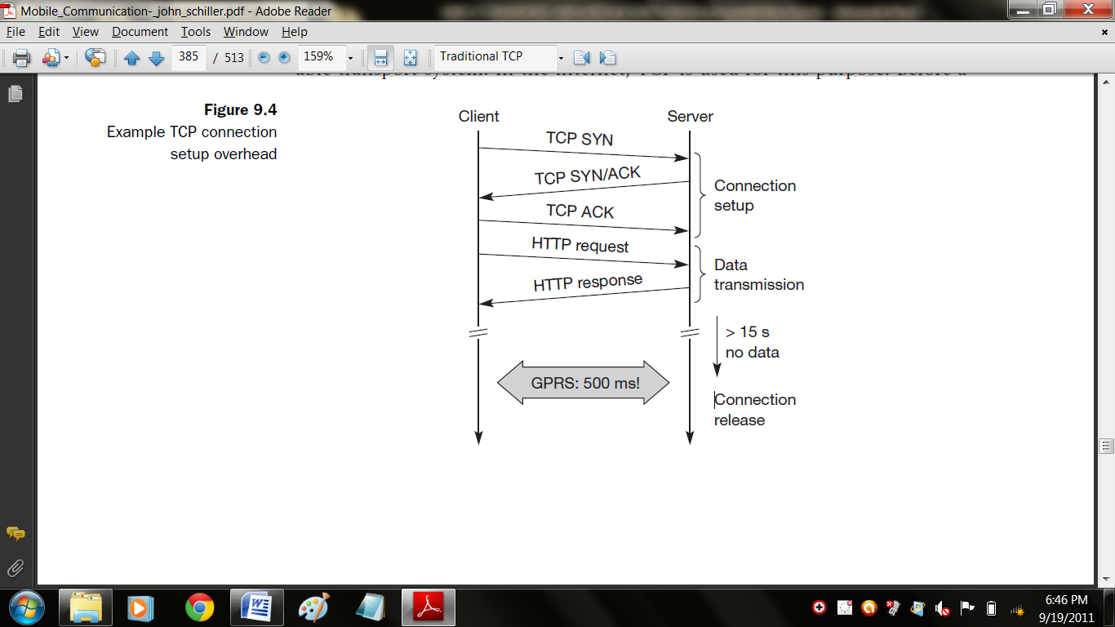
Web services are based on HTTP which requires a reliable transport system. In the internet, TCP is used for this purpose. Before a HTTP request can be transmitted the TCP connection has to be established. This already requires three messages. If GPRS is used as wide area transport system, one-way delays of 500 ms and more are quite common. The setup of a TCP connection already takes far more than a second.
This led to the development of a transaction-oriented TCP. T/TCP can combine packets for connection establishment and connection release with user data packets. This can reduce the number of packets down to two instead of seven. Similar considerations led to the development of a transaction service in WAP.
The obvious advantage for certain applications is the reduction in the overhead which standard TCP has for connection setup and connection release. However, T/TCP is not the original TCP anymore, so it requires changes in the mobile host and all correspondent hosts, which is a major disadvantage. This solution no longer hides mobility. Furthermore, T/TCP exhibits several security problems.
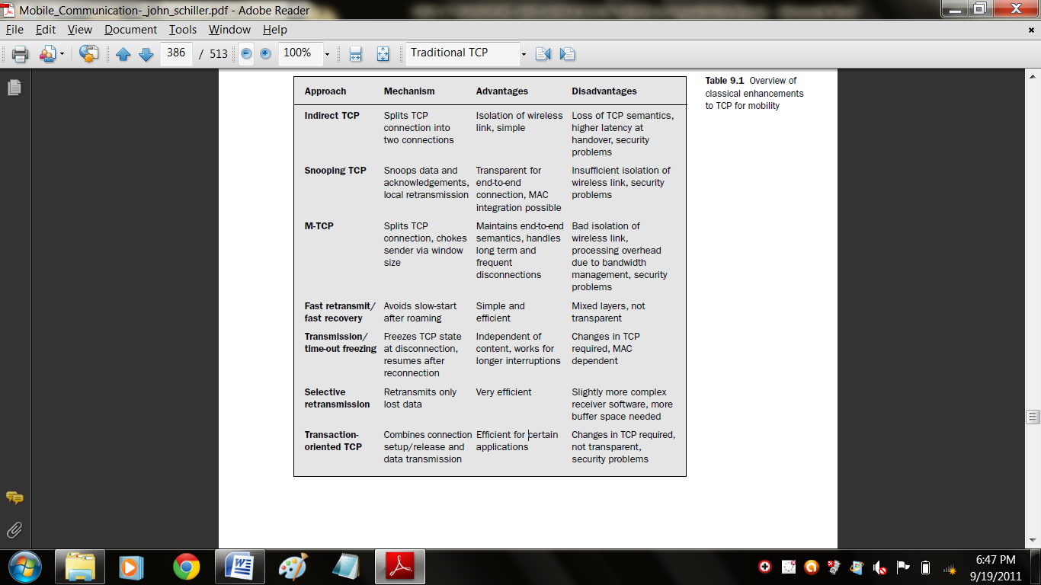

Table shows an overview of the classical mechanisms presented together with some advantages and disadvantages. The approaches are not all exclusive, but can be combined. Selective retransmission, for example, can be used together with the others and can even be applied to fixed networks.
An additional scheme that can be used to reduce TCP overhead is header compression. Using tunneling schemes as in mobile IP together with TCP, results in protocol headers of 60 byte in case of IPv4 and 100 byte for IPv6 due to the larger addresses. Many fields in the IP and TCP header remain unchanged for every packet. Only just transmitting the differences is often sufficient. Especially delay sensitive applications like, e.g., interactive games, which have small packets benefit from small headers. However, header compression experiences difficulties when error rates are high due to the loss of the common context between sender and receiver. With the new possibilities of wireless wide area networks (WWAN) and their tremendous success, the focus of research has shifted more and more towards these 2.5G/3G networks. Up to now there are no final solutions to the problems arising when TCP is used in WWANs. However, some guidelines do exist.

3. Wireless application protocol
The growth of the internet, internet applications, and mobile communications led to many early proprietary solutions providing internet services for mobile, wireless devices. The version 1.x of WAP and the standards are still known as WAP Forum standards. The basic objectives of the WAP Forum and now of the OMA are to bring diverse internet content (e.g., web pages, push services) and other data services (e.g., stock quotes) to digital cellular phones and other wireless, mobile terminals (e.g., PDAs, laptops). Moreover, a protocol suite should enable global
wireless communication across different wireless network technologies, e.g., GSM, CDPD, UMTS etc. The forum is embracing and extending existing standards and technologies of the internet wherever possible and is creating a framework for the development of contents and applications that scale across a very wide range of wireless bearer networks and wireless device types.

All solutions must be:
- Interoperable, i.e., allowing terminals and software from different vendors to communicate with networks from different providers;
- Scalable, i.e., protocols and services should scale with customer needs and number of customers;
- Efficient, i.e., provision of QoS suited to the characteristics of the wireless and mobile networks;
- Reliable, i.e., provision of a consistent and predictable platform for deploying services; and
- Secure, i.e., preservation of the integrity of user data, protection of devices and services from security problems.

3.1 Architecture
Figure gives an overview of the WAP architecture, its protocols and components, and compares this architecture with the typical internet architecture when using the world wide web. This comparison is often cited by the WAP Forum and it helps to understand the architecture. This comparison can be misleading as not all components and protocols shown at the same layer are comparable. For consistency reasons with the existing specification, the following stays with the model as shown in Figure. The basis for transmission of data is formed by different bearer services. WAP does not specify bearer services, but uses existing data services and will integrate further services. Examples are message services, such as short message service (SMS) of GSM, circuit-switched data, such as high-speed circuit switched data (HSCSD) in GSM, or packet switched data, such as general packet radio service (GPRS) in GSM. Many other bearers are supported, such as CDPD, IS-136, PHS. No special interface has been specified between the bearer service and the next higher layer, the transport layer with its wireless datagram protocol (WDP) and the additional wireless control message protocol (WCMP), because the adaptation of these protocols are bearer-specific.
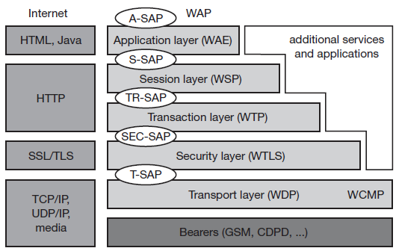

The transport layer offers a bearer independent, consistent datagram-oriented service to the higher layers of the WAP architecture. Communication is done transparently over one of the available bearer services. The transport layer service access point (T-SAP) is the common interface to be used by higher layers independent of the underlying network. The next higher layer, the security layer with its wireless transport layer security protocol WTLS offers its service at the security SAP (SEC-SAP). WTLS is based on the transport layer security (TLS, formerly SSL, secure sockets layer) already known from the www. WTLS has been optimized for use in wireless networks with narrow-band channels. It can offer data integrity, privacy, authentication, and (some) denial-of-service protection.
The WAP transaction layer with its wireless transaction protocol (WTP) offers a lightweight transaction service at the transaction SAP (TR-SAP). This service efficiently provides reliable or unreliable requests and asynchronous transactions. Tightly coupled to this layer is the next higher layer, if used for connection-oriented service. The session layer with the wireless session protocol (WSP) currently offers two services at the session-SAP (S-SAP), one connection-oriented and one connectionless if used directly on top of WDP. A special service for browsing the web (WSP/B) has been defined that offers HTTP/1.1 functionality, long-lived session state, session suspend and resume, session migration and other features needed for wireless mobile access to the web. Finally the application layer with the wireless application environment (WAE) offers a framework for the integration of different www and mobile telephony applications. It offers many protocols and services with special service access points. The main issues here are scripting languages, special markup languages, interfaces to telephony applications, and many content formats adapted to the special requirements of small, handheld, wireless devices.
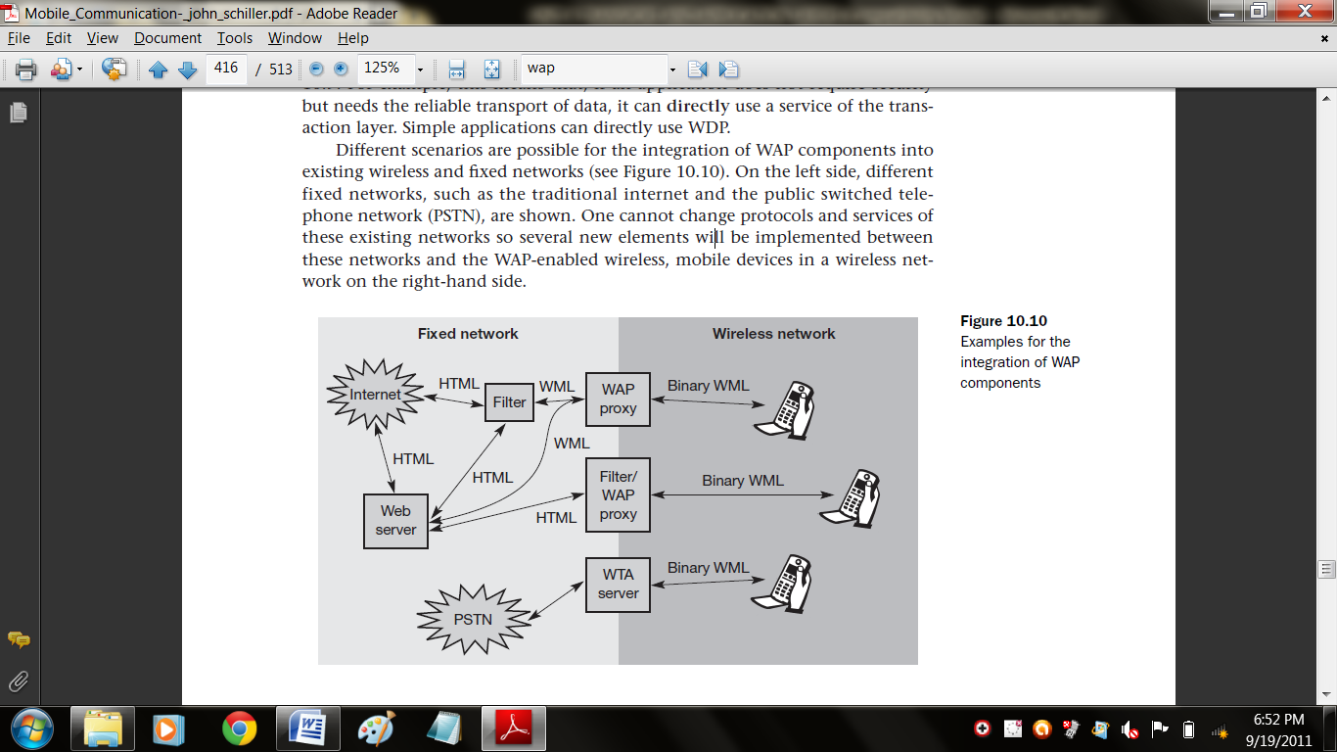
Figure not only shows the overall WAP architecture, but also its relation to the traditional internet architecture for www applications. The WAP transport layer together with the bearers can be (roughly) compared to the services offered by TCP or UDP over IP and different media in the internet. If a bearer in the WAP architecture already offers IP services (e.g., GPRS, CDPD) then UDP is used as WDP. The TLS/SSL layer of the internet has also been adopted for the WAP architecture with some changes required for optimization. The functionality of the session and transaction layer can roughly be compared with the role of HTTP in the web architecture.
However, HTTP does not offer all the additional mechanisms needed for efficient wireless, mobile access (e.g., session migration, suspend/resume). Finally, the application layer offers similar features as HTML and Java. Again, special formats and features optimized for the wireless scenario have been defined and telephony access has been added. WAP does not always force all applications to use the whole protocol architecture. Applications can use only a part of the architecture as shown in Figure. For example, this means that, if an application does not require security but needs the reliable transport of data, it can directly use a service of the transaction layer. Simple applications can directly use WDP.
Different scenarios are possible for the integration of WAP components into existing wireless and fixed networks. On the left side, different fixed networks, such as the traditional internet and the public switched telephone network (PSTN), are shown. One cannot change protocols and services of these existing networks so several new elements will be implemented between these networks and the WAP-enabled wireless, mobile devices in a wireless network on the right-hand side.
The current www in the internet offers web pages with the help of HTML and web servers. To be able to browse these pages or additional pages with handheld devices, a wireless markup language (WML) has been defined in WAP. Special filters within the fixed network can now translate HTML into WML, web servers can already provide pages in WML, or the gateways between the fixed and wireless network can translate HTML into WML. These gateways not only filter pages but also act as proxies for web access. WML is additionally converted into binary WML for more efficient transmission. In a similar way, a special gateway can be implemented to access traditional telephony services via binary WML. This wireless telephony application (WTA) server translates, e.g., signaling of the telephone network (incoming call etc.) into WML events displayed at the handheld device. It is important to notice the integrated view for the wireless client of all different services, telephony and web, via the WAE.

3.1 Wireless telephony application
Browsing the web using the WML browser is only one application for a handheld device user. Say a user still wants to make phone calls and access all the features of the mobile phone network as with a traditional mobile phone. This is where the wireless telephony application (WTA), the WTA user agent, and the wireless telephony application interface WTAI come in. WTA is a collection of telephony specific extensions for call and feature control mechanisms, merging data networks and voice networks.
The WTA framework integrates advanced telephony services using a consistent user interface (e.g., the WML browser) and allows network operators to increase accessibility for various special services in their network. A network operator can reach more end-devices using WTA because this is integrated in the wireless application environment (WAE) which handles device-specific characteristics and environments. WTA should enable third-party developers as well as network operators to create network-independent content that accesses the basic features of the bearer network. However, most of the WTA functionality is reserved for the network operators for security and stability reasons.

WTA extends the basic WAE application model in several ways:
- Content push: A WTA origin server can push content, i.e., WML decks or WMLScript, to the client. A push can take place without prior client request. The content can enable, e.g., the client to handle new network events that were unknown before.
- Access to telephony functions: The wireless telephony application interface provides many functions to handle telephony events (call accept, call setup, change of phone book entries etc.).
- Repository for event handlers: The repository represents a persistent storage on the client for content required to offer WTA services. Content are either channels or resources. Examples for resources are WML decks, WMLScript objects, or WBMP pictures. Resources are loaded using WSP or are pre-installed. A channel comprises references to resources and is associated with a lifetime. Within this lifetime, it is guaranteed that all resources the channel points to are locally available in the repository. The motivation behind the repository is the necessity to react very quickly for time-critical events (e.g., call accept). It would take too long to load content from a server for this purpose.
- Security model: Mandatory for WTA is a security model as many frauds happen with wrong phone numbers or faked services. WTA allows the client to only connect to trustworthy gateways, which then have to check if the servers providing content are authorized to send this content to the client. Obviously, it is not easy to define trustworthy in this context. In the beginning, the network operator’s gateway may be the only trusted gateway and the network operator may decide which servers are allowed to provide content. These libraries have been defined in the WTAI specification (WAP Forum, 2000m) and allow for the creation of telephony applications using the WTA user agent. Library functions can be used from WML decks or WMLScript.

Three classes of libraries have been defined:

- Common network services: This class contains libraries for services common to all mobile networks. The call control library contains, e.g., functions to set up, accept, and release calls. Network text contains functions to send, read, and delete text messages. Phonebook allows for the manipulation of the local phonebook entries (e.g. read, write, delete). Finally, the library miscellaneous contains, e.g., a function to indicate incoming data, e-mail, fax, or voice messages.
- Network specific services: Libraries in this class depend on the capabilities of the mobile network. Additionally, this class might contain operator specific libraries.
- Public services: This class contains libraries with publicly available functions, i.e., functions third-party providers may use, not just network operators. One example is “make call” to set up a phone call.

The execution of a new service in the user agent can happen in several ways:
- Based upon a user request or another service a URI plus content stored in the repository can be used. This is (roughly) comparable with the access to cached items in a web browser.
- The user agent can also access a URI via the WTA server. In this case, the URI plus content was not stored in the repository.
- A server can push a message to the client as explained in the context of service indication.
- Finally, any network event can trigger the execution of a new service. The client has to translate the event into a URI which then can be processed by the WTA user agent. For example, an incoming call plus required parameters may be accepted via “Accept Call”.
Figure gives an overview of the WTA logical architecture. The components shown are not all mandatory in this architecture; however, firewalls or other origin servers may be useful. A minimal configuration could be a single server from the network operator serving all clients. The client is connected via a mobile network with a WTA server, other telephone networks (e.g., fixed PSTN), and a WAP gateway. A WML user agent running on the client or on other user agents is not shown here. The client may have voice and data connections over the mobile network. Other origin servers within the trusted domain may be connected via the WAP gateway.
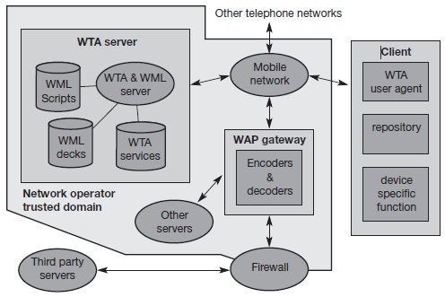

A firewall is useful to connect third-party origin servers outside the trusted domain. One difference between WTA servers and other servers besides security is the tighter control of QoS. A network operator knows (more or less precisely) the latency, reliability, and capacity of its mobile network and can have more control over the behavior of the services. Other servers, probably located in the internet, may not be able to give as good QoS guarantees as the network operator.
Similarly, the WTA user agent has a very rigid and real-time context management for browsing the web compared to the standard WML user agent. Figure shows an exemplary interaction between a WTA client, a WTA gateway, a WTA server, the mobile network (with probably many more servers) and a voice box server. Someone might leave a message on a voice box server as indicated. Without WAP, the network operator then typically generates an SMS indicating the new message on the voice box via a little symbol on the mobile phone. However, it is typically not indicated who left a message, what messages are stored etc. Users have to call the voice box to check and cannot choose a particular message.
In a WAP scenario, the voice box can induce the WTA server to generate new content for pushing to the client. An example could be a WML deck containing a list of callers plus length and priority of the calls. The server does not push this deck immediately to the client, but sends a push message containing a single URL to the client. A short note, e.g., “5 new calls are stored", could accompany the push message. The WTA gateway translates the push URL into a service indication and codes it into a more compact binary format. The WTA user agent then indicates that new messages are stored.
If the user wants to listen to the stored messages, he or she can request a list of the messages. This is done with the help of the URL. A WSP get requests the content the URL points to. The gateway translates this WSP get into an HTTP get and the server responds with the prepared list of callers. After displaying the content, the user can select a voice message from the list. Each voice message in this example has an associated URL, which can request a certain WML card from the server. The purpose of this card is to prepare the client for an incoming call. As soon as the client receives the card, it waits for the incoming call. The call is then automatically accepted. The WTA server also signals the voice box system to set up a (traditional) voice connection to play the selected voice message. Setting up the call and accepting the call is shown using dashed lines, as these are standard interactions from the mobile phone network, which are not controlled by WAP.
The following examples illustrate the integration of WTA, WTAI library calls, WML and WMLScript, and how authors can use the functions of WTA. Imagine you are watching a show on TV. At the end of the show, you may vote for your personal champion. The traditional method is that each candidate gets an associated phone number and you have to dial the number this is quite error-prone if long numbers are used.
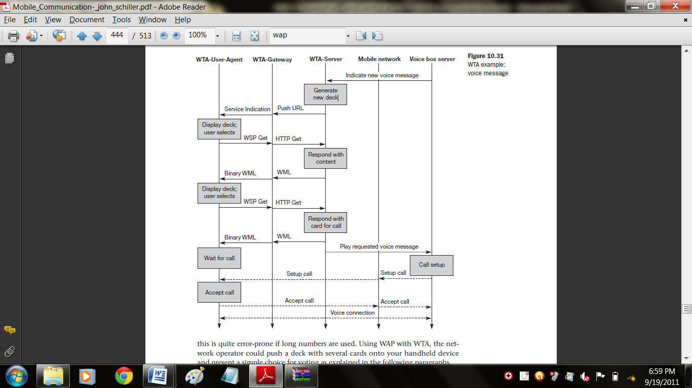

Using WAP with WTA, the network operator could push a deck with several cards onto your handheld device and present a simple choice for voting as explained in the following paragraphs.

3.2 Wireless application environment
The main idea behind the wireless application environment (WAE) is to create a general-purpose application environment based mainly on existing technologies and philosophies of the world wide web. This environment should allow service providers, software manufacturers, or hardware vendors to integrate their applications so they can reach a wide variety of different wireless platforms in an efficient way. However, WAE does not dictate or assume any specific man-machine-interface model, but allows for a variety of devices, each with its own capabilities and probably vendor-specific extras (i.e., each vendor can have its own look and feel). WAE has already integrated the following technologies and adapted them for use in a wireless environment with low power handheld devices. HTML), JavaScript, and the handheld device markup language HDML form the basis of the wireless markup language (WML) and the scripting language WMLscript. The exchange formats for business cards and phone books vCard and for calendars vCalendar have been included. URLs from the web can be used.
A wide range of mobile telecommunication technologies have been adopted and integrated into the wireless telephony application (WTA) (WAP Forum, 2000f). Besides relying on mature and established technology, WAE focuses on devices with very limited capabilities, narrow-band environments, and special security and access control features. The first phase of the WAE specification developed a whole application suite, especially for wireless clients as presented in the following sections. Future developments for the WAE will include extensions for more content formats, integration of further existing or emerging technologies, more server side aspects, and the integration of intelligent telephone networks.

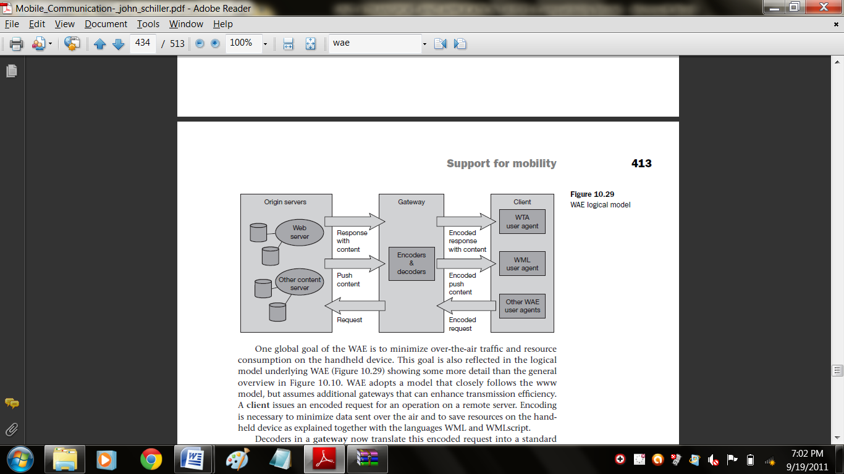

One global goal of the WAE is to minimize over-the-air traffic and resource consumption on the handheld device. WAE adopts a model that closely follows the www model, but assumes additional gateways that can enhance transmission efficiency.
A client issues an encoded request for an operation on a remote server. Encoding is necessary to minimize data sent over the air and to save resources on the handheld device as explained together with the languages WML and WMLscript. Decoders in a gateway now translate this encoded request into a standard request as understood by the origin servers. This could be a request to get a web page to set up a call. The gateway transfers this request to the appropriate origin server as if it came from a standard client. Origin servers could be standard web servers running HTTP and generating content using scripts, providing pages using a database, or applying any other (proprietary) technology. WAE does not specify any standard content generator or server, but assumes that the majority will follow the standard technology used in today’s www.
The origin servers will respond to the request. The gateway now encodes the response and its content (if there is any) and transfers the encoded response with the content to the client. The WAE logical model not only includes this standard request/response scheme, but it also includes push services. Then an origin server pushes content to the gateway. The gateway encodes the pushed content and transmits the encoded push content to the client. Several user agents can reside within a client. User agents include such items as: browsers, phonebooks, message editors etc. WAE does not specify the number of user agents or their functionality, but assumes a basic WML user agent that supports WML, WMLscript, or both (i.e., a ‘WML browser’). Further domain specific user agents with varying architectures can be implemented. Again, this is left to vendors. However, one more user agent has been specified with its fundamental services, the WTA user agent. This user agent handles access to, and interaction with, mobile telephone features (such as call control). As over time many vendor dependent user agents may develop, the standard defines a user agent profile (UAProf), which describes the capabilities of a user agent. Capabilities may be related to hardware or software. Examples are: display size, operating system, browser version, processor, memory size, audio/video codec, or supported network types.

3.3 WAP 2.0
In July 2001, version two of the wireless application protocol (WAP 2.0) was published by the WAP Forum. All standards can be downloaded from the web (OMA, 2002). It can be stated that WAP 2.0 is roughly the sum of WAP 1.x, i-mode, Internet protocols, and many mobility specific enhancements. WAP 2.0 continues to support WAP 1.x protocols, but additionally integrates IP, TCP (with a wireless profile), TLS, and HTTP (wireless profiled). WAP 2.0 browsers support WML as well as XHTML with a mobile profile (XHTMLMP). XHTML is the extensible hypertext mark-up language developed by the W3C (2002) to replace and enhance the currently used HTML.
WAP 2.0 uses the composite capabilities/ preference profiles (CC/PP) framework for describing user preferences and device capabilities. CC/PP provides the technical basis for the UAProf device profile function

Figure gives an overview of the WAP 2.0 architecture as specified in WAP Forum. The protocol framework consists of the following four components:
- Bearer networks: Similar to WAP 1.x, many bearers are supported. Typical bearers today are GPRS in GSM networks, SMS for push services. Third generation networks will directly offer IP services.
- Transport services: These services offer an end-to-end abstraction on top of different bearers. Transport services can be either connection-oriented or connectionless. For reliable, connection-oriented services TCP with a wireless profile can be used. WDP or UDP (in case of an IP bearer) can be used for unreliable, connectionless (datagram) services.

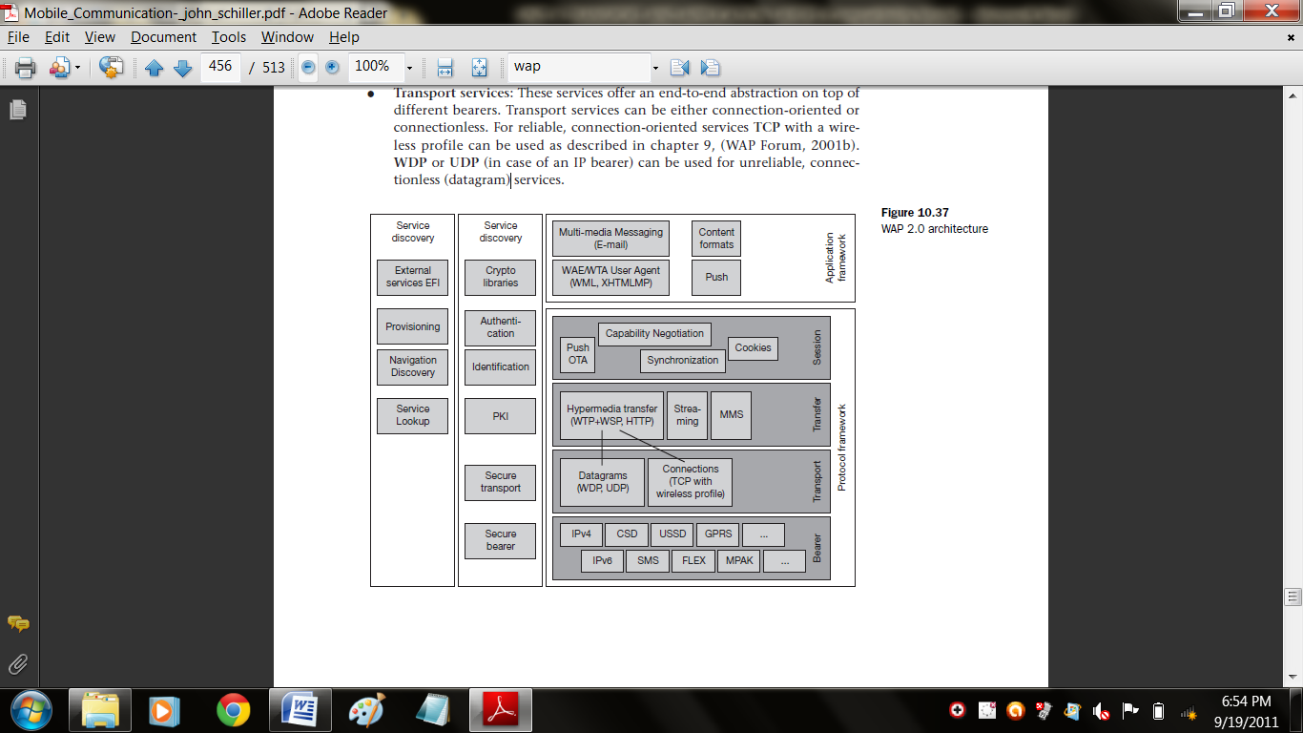

- Transfer services: Examples for transfer protocols are a wireless profiled HTTP, the combination of WTP/WSP, streaming protocols, and message transfer protocols. While the hypermedia transfer protocols can be used for web browsing, streaming protocols provide tight time-bounds to support isochronous data (audio and video). The multimedia messaging service (MMS) transfers asynchronous multi-media content (WAP Forum, 2001d). MMS supports different media types, such as JPEG, GIF, text, and AMR coded audio. There is no fixed upper bound for the message size. Depending on the network operator and device capabilities, typical sizes are 30–100 kbyte. MMS is already offered by many providers.
- Session services: As discussed in the beginning of this chapter, mobile devices need a shared state between network elements to operate efficiently. CC/PP can be used for capability negotiation. This includes information about client, server, and proxy capabilities, and allows for customization of content. The push OTA service offers reliable and unreliable push services. The cookie service has been adopted from the Internet. This service can establish state on a client that survives multiple hypermedia transfers.

Finally, a synchronization service has been defined for synchronizing replicated data. The application framework comprises the basic applications needed for browsing, support of different content formats, e-mail service etc. This framework was developed to establish an interoperable application environment for many different vendors, service providers, and network operators. The WAE/WTA user agent supports WML known from WAP 1.x as well as XHTML mobile profile. This includes scripting, stylesheets, telephony applications, and programming interfaces adapted to mobile devices. The applications for multi-media messaging and push services are also located in this framework. Finally, many content formats have to be supported: color images, audio, video, calendar information, phone book entries etc. Mobile devices require extensive security services. Just imagine someone pushing many messages on a mobile device that let the device access certain web pages repeatedly. This might cause heavy air traffic that has to be paid for by the user! The user might not even notice anything from this attack as the mobile device is always-on, exchanging data without user interaction.
The security services have to cover the traditional aspects of security, e.g., privacy, authentication, integrity, and non-repudiation. Cryptographic libraries are needed for signing data at the application level. Authentication services offer several mechanisms to authenticate servers, proxies, and clients at different levels. For example, at the transport layer WTLS or TLS may be used. The wireless identity module (WIM) provides the functions needed for user identification and authentication. Many business models rely on customer identification. In general, public key infrastructures (PKI) can be used for the management of public-key cryptography and certificate exchange. WTLS provides secure transport over datagram protocols, while TLS is used for connection-oriented transport protocols (TCP).
Finally, some bearer networks already provide security functions, e.g., IPSec for IP networks. Service discovery is particularly important for mobile devices. External functions or services on a device (i.e., outside the WAP specification, typically vendor dependent) can be discovered via the external functionality interface (EFI) as specified in WAP Forum. For many network services, a device needs additional parameters to get access (e.g., bootstrap information, user agent behavior, smart card specification, content type information). The device can get these parameters via the provisioning service (WAP Forum, 2001m). While surfing through the network using hypermedia documents the device may need to discover new network services. The navigation discovery provides a secure way to do this. The service lookup provides for the discovery of parameters needed for a certain service with the help of a directory.
The domain name system (DNS) is an example mapping a name onto an IP address. It should be noted that the components listed for security services and service discovery cannot be assigned to only one layer. Instead, the services may span several layers in the protocol architecture. Up to now, not all of the services have been fully specified and, thus, the reader should check for changes in the specifications. Figure shows four examples of protocol stacks using WAP 2.0 components. The stacks in the upper left corner show the classical WAP 1.x configuration with a WAP gateway translating between internet and WAP protocols.
The upper right corner illustrates protocol stacks similar to those used in i-mode. The WAP proxy translates the unchanged HTTP/TCP from the internet into profiled versions of these protocols. The lower left corner shows a WAP proxy tunneling HTTP over TLS. This architecture offers true end-to-end security which contrasts with the example in the upper left corner that breaks the security association in the gateway. The example in the lower right corner finally shows that WAP 2.0 does not necessarily need a proxy. The WAP device can directly access internet content. Although proxies are not required in WAP 2.0, they may enhance the performance (profiled TCP, profiled HTTP, compression etc.).

Part-A

- Show a diagrammatic representation for snooping TCP that act as a transparent TCP extension.
- How the selective retransmission differ from go-back-n retransmission?
- What is the goal of M- TCP?
- Mention the reasons lead to a reduction of congestion threshold in fast transmit/fast recovery.
- What are the advantages of the WAP forum?
- Draw the WAP architecture with component and interfaces.
- What are the classes of libraries available in WTA?
- What is the main idea behind the WAE?
- Draw the logical model for WAE.
- What are the components available in protocol framework?

Part-B
- Discuss in detail about the traditional TCP.(16)
- Explain the following,
i) Fast retransmit/ Fast recovery and Transmission/ Time out freezing. (8)
ii) Selective retransmission and Transaction oriented TCP.(8)
- Discuss the concept of Indirect TCP.
- Describe in detail about the WAP & its architecture.(16)
- Explain about the wireless telephony application with an example.(16)
- i) Explain about the wireless Application Environment. (8)
ii) Write a detailed note on WAP 2.0 architecture. (8)

